Morris Area Genealogy Society
Board Meeting
Agenda – Rev1 (attach Attachment 2)
Rev 2 – in Red
May 12, 2017
12:00 to 3:00p.m.

Voting Board Members:
S.Kehr , President S.Simon, VP/PC; Trustee Past Pres.
N.Lack , Treas. <Open>, Corr.Sec. C.Flatley, Rec.Sec.
M. Solomon, Trustee; SP M.Keane, Trustee L.Foster, Pres.Em.

Committees & Others:
R.Lindsay, Historian C.Flatley, Hosp. L.Foster, Indexing, Research
C.Kissil, Lib.Liaison L.Mathew, Memb. L.Heinzerling, Name Tags
J.Short//M.Corson, B&B MJ Solomon, Newsltr; SP M.Corson, Publicity
S.Kehr, Webmaster, Speakers Bureau E.Simon, Surnames
J. Short, DNA B.Stein, Cross Pond R.Daniels, SIGS Coord.
L.Andrews, German & EE S. Newsome, Italian & WE
---------------------------------------------------------------------------------------------------------------------

Minutes from March 2017 – ATTENDEES: PLEASE READ BEFORE MEETING - Carole F

Old Business

Nominating Committee – thank you – Susan K

Salmon Fund – update from MMTL – Susan K

MAGS Archive Responsibility Checklist – Roy – see Attachment 2

Increasing number of Trustees – Susan S

Amend ByLaws to add Webmaster as a committee – Nancy L

New Business

Annual Report – Susan K

Room Lottery – Susan K

Speaker Fee – Martha C.
New folder – Roy – see Attachment 1
Newspapers are not printing our press release - Roy
MAGS Magnetic stickers to place on back of our cars – Roy
General Reports

Treasurer’s Report - Nancy

Corresponding Secretary – Susan K
Annual Donation to MMTL – thank you’s received

Committee Reports

Programs –Susan S

Membership – Linda M

Historian - Roy

Index Group - Linnea

Newsletter - Mary-Jo

Publicity – Martha

Refreshments - Carole F

Research – Linnea

SIGS Coordinator – Ruth

Speakers Bureau – Susan K
Webmaster received inquiry for Bob Stein for German Presentation.

Websites – Susan K
MAGs Public Website
MAGS Audio Website

Special Projects – Mary-Jo
Hilltop Presbyterian Church –
First Baptist Church (Roy)
Lake Hopatcong Historical Society/Museum (Roy)
Parsippany Historical and Preservation Society
Boonton Historical Society

Transfer of Business Papers
President Susan Kehr to: Ruth Daniels
VP/Pgm Chair Susan Simon to: Martha Corson
Corr. Secty [temp Susan Kehr] to: Susan Simon
Publicity Martha Corson to: Mary-Jo Solomon
Newsletter Mary-Jo Solomon to: Jeff Remaly
Adjournment
ATTACHMENT 1

Re: new folder for Series III
From: Ruth Daniels <magsociety@yahoo.com> Apr 13 at 8:34 PM
To Roy Lindsey ; Susan Kehr (MAGS)
CC: Simon Susan ; Claire Kissil ; LBFmags@aol.com ; ginnywal@verizon.net ; ctmathew@optonline.net ; Mary Keane; Ruth Daniels

Message body
Could the MAGS Decorations file/photos go in the Photographs Box (2003-2005) with the date extended? I don't think the date was meant to be a limiting date, but just showing the dates that are in there.
Ruth D
New email: rudannj@gmail.com

From: Roy Lindsey <rdbdlindsey@optonline.net>
To: Susan Kehr (MAGS) <s_kehr@yahoo.com>
Cc: Ruth Daniels <magsociety@yahoo.com>; Simon Susan <slsimon@optonline.net>; Claire Kissil <kissil@verizon.net>; LBFmags@aol.com; ginnywal@verizon.net; ctmathew@optonline.net; Mary Keane <bandkfamilytree@gmail.com>
Sent: Thursday, April 13, 2017 4:49 PM
Subject: new folder for Series III
Susan,
We need to consider another folder for Series III. Last year a MAGs History placed in the NJHGC collection. From my annual Historian report, MAGS History was to be filed in Series III – box 7 folder 8. Series III: Administrative files, Research Groups 1987-2015, folder 8 is Policies and Procedures. Perhaps Claire can confirm. Looking at the Boxes and folders in Series III, I don’t seem to find a more appropriate match.
http://morristownlibrary.org/HCFindingAids/MAGS.xml
This year we are creating two addition reports/documents that don’t seem to fit any of the current folders. One is document with MAGS Decorations and the second is a history of indexing by Linnea. I would like for both of these too be added to the archive collections.
It is suggested that we add another folder to Box 7 for these type documents. Just need a name.
Roy
Another email from Roy:
Need to discuss a new folder for some of the new documents we have created in the last two years as shown below.
Suggesting: Series III, Box 7, Folder 16: History and Other Special Program Reports
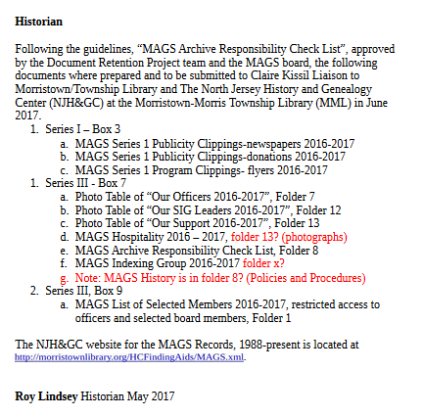
Morris Area Genealogy Society Indexing Group
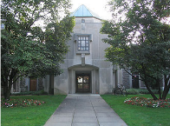
The MAGS Indexing Group was formed in 1996 with the goal of indexing material in the collection of the North Jersey History and Genealogy Center (NJHGC) of the Morristown & Morris Township Library.
One of the first projects was “Index of Interments in Greenwood Cemetery, Boonton, New Jersey, 1872-1965” followed by “Index to Morris County History 1881-1892: A Monthly Synopsis of Local Events Compiled from the Newspaper The Dover Iron Era.”
In 2009, an index to the first twenty volumes of the MAGS Newsletter was completed. Each year since, an index to the current volume has been prepared. Another project has been the preparation of indexes to twenty-three books in the Images of America series published by Arcadia Publishing which relate to Morris County and surrounding areas. These indexes and others prepared by the Group are in the collection of NJHGC and on the MAGS public Website
(http://www.rootsweb.ancestry.com/~njmags/)
In 2014 the Library was given an extensive collection of death certificates, newspaper clippings of obituaries and some birth and marriage certificates by George H. Coulthard, a longtime Morris area genealogist. The collection has been organized by town or area and in many cases by cemetery. Indexing of the entire collection is in process.
For many years the Group met for a morning work session once a month eventually adding an occasional all-day session. Currently all sessions are monthly on a Saturday from morning to mid-afternoon.
Current members of the Indexing Group are Martha Corson, Ruth Daniels, Linnea Foster, Evelyn Huey, Susan Kehr, Linda Mathew, Stephanie Reidinger, Marianne Totaro, Ginny Walton
Other MAGS members who have participated were Helen Benz, Eleanor Casagrand, Barbara Davidson, William Graves, Harriet Hollema, Bogert Holly, Leroy May, Amie McDonald, Janet Meissner, William Monroe, Anna Nagy, Stuart Shippey, Regina Springer, Judy Weinstein, Henry Weis, Lois Weis, Carl Yates, Maria Young.

Linnea B. Foster
Indexing Group Coordinator
April 2017

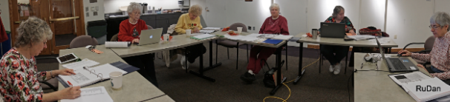
Left to Right MMTL Meeting Room
Linda Stephanie Evelyn Ginny Susan Martha
Mathew Reidinger Huey Walton Kehr Corson

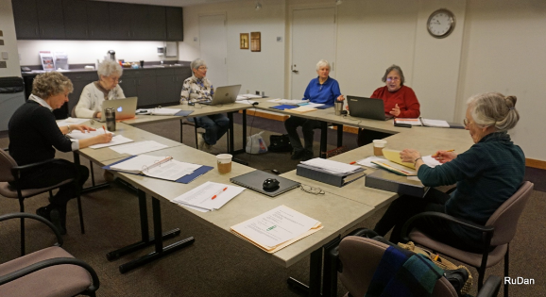
Left to Right MMTL Meeting Room
Linda Stephanie Martha Ginny Susan Linnea
Mathew Reidinger Corson Walton Kehr Foster

Left to Right NJHGC Library Area
Marianne Stephine Non Mags Linda Susan Martha Ginny Evelyn
Totaro Reidinger person Mathew Kehr Corson Walton Huey

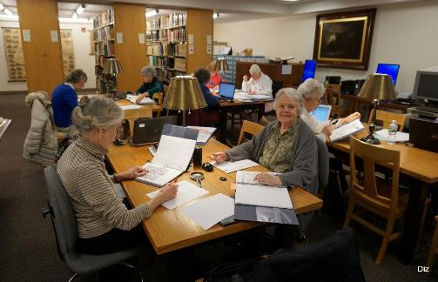
Left to Right NJHGC Library Area
Linda Linnea Martha Susan Evelyn Ginny Ruth Stephanie
Mathew Foster Corson Kehr Huey Walton Daniels Reidinge
Indexing Members
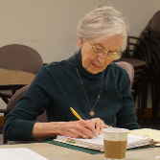 | 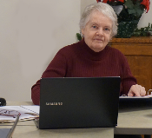 | 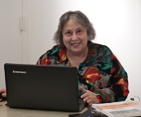
Linnea Foster | Ruth Daniels | Susan Kehr
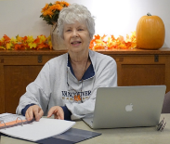 | 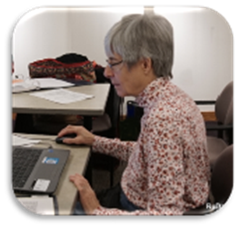
Stephanie Reidinger | Martha Corson | Linda Mathew
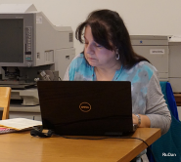 | 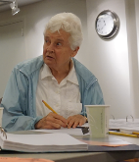 | 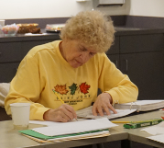
Marianne Totaro | Ginny Walton | Evelyn Huey

ATTACHMENT 2

